Sensing in Lithium-Ion Based Battery Management System

Akshiv Agrawal

*Department of Electrical & Electronics Engineering*

*Birla Institute of Technology Mesra, Jaipur Campus*

Rajasthan, India

akshivagrawal@gmail.com

Mohit Sharma

*Department of Electrical & Electronics Engineering*

*Birla Institute of Technology Mesra, Jaipur Campus*

Rajasthan, India

mohit112714@gmail.com

Dr. Deepak Verma

*Department of Electrical & Electronics Engineering*

*Birla Institute of Technology Mesra, Jaipur Campus*

Rajasthan, India

deepakverma16@gmail.com

*Abstract*— Lithium-ion rechargeable batteries when used on a large scale requires a battery management system to provide safety to operators and battery itself. To protect it from over-charge, over-discharge, thermal runaway, for estimation of state of charge (SOC) and state of health (SOH), we use Battery Management System and to do so, battery management system needs to measure voltage, current, temperature. This is achieved by using flash analog to digital convertor (ADC), successive approximation, delta sigma ADC for sensing voltage, thermocouple, thermistor, voltage divider circuit for measuring temperature, resistive shunt, hall effect mechanism for measuring current. In this paper the sensing functionality of battery management system like sensing voltage, current and temperature is presented.

Keywords— Lithium-ion batteries, battery management system, over-charge, over-discharge, state of charge (SOC), state of health (SOH), analog to digital convertor (ADC), delta sigma ADC, thermocouple, thermistor, resistive shunt, hall effect mechanism.

# Introduction

In the recent past years, usage of secondary battery modules/packs (many rechargeable batteries connected in series and parallel connection) suddenly escalate because of the expansion in market of renewable sources of energy as amount of greenhouse gases increase on earth due to burning of fossils fuels. Large battery packs require for storage of excess high voltage energy from renewable resources.

Rechargeable battery packs are also used in EVs and HEVs and as we know there is also a sudden increase in market of HEVs (Hybrid Electric Vehicles) and EVs (Electric Vehicle) because of its low cost, no transmission of Carbon monoxide(CO).

Li-ion (Lithium ion), Ni-Cd (Nickel-Cadmium), Ni-MH (Nickel-Metal hydride), Pb-A (Lead Acid), Li-Po (Lithium Polymer) batteries are generally the most common used batteries available but Li-ion batteries are mostly used in automobile, mobile and renewable energy industry because of its low self-discharge rate, high energy density, long life, ability to retains most of their charge for many months, low maintenance. However Li-ion batteries have some disadvantages which are high cost, less stability at high temperature, current and require safety precautions, complex structure, requires a special circuity to maintain its performance [1].

To increase Li-ion battery performance, increase its life, detect unsafe operating conditions, protect cell from damage at failures, protect users, a special circuitry is used which is called battery management system.

Battery management has several functions like sensing voltage, current, temperature, ground fault detection, state of charge estimation (SOC), state of health estimation (SOH), state of life (SOL) estimation, range estimation, thermal management, data recorder, balancing cells, power limit computation, abuse detection, protection against over-charge, over-discharge, short circuit, very high temperature [2].

So for sensing voltage Analog to Digital convertor used as they convert analog voltage supply ( when batteries connect with load) into digital value and counts. Thus it helps us to find voltage which is required for BMS to estimate state of charge (SOC) [3]. For measuring temperature we need sensor like thermistor or thermocouple which convert temperature to voltage and measure voltage by A/D. Same for measuring current shunt resistor sensor or hall effect mechanism convert current into voltage and measured voltage by A/D.

A structure of battery management system as shown in fig. 1 [4].

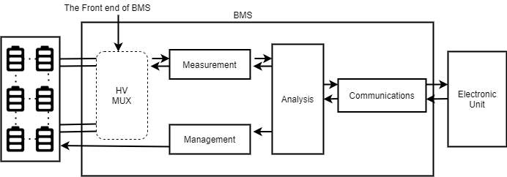

1. Battery Management System [4].

# Recent Advancements in Lithium-Ion Batteries

There are many recent advancements in lithium ion batteries. To obtain certain properties different elements are added in the structure of lithium ion batteries. For example, if we want high specific energy then we use Lithium Cobalt Oxide.

## Lithium Cobalt Oxide ($LiCoO_{2}$)

Lithium Cobalt Oxide was first made by Sony and Mizushima improved the material [5]. In this type of battery Cobalt Oxide is used as cathode and graphite as anode. The cathode is a layered structure and allows lithium ion to move at the time of charging and discharging. It is also known as LCO. It allows 2-D intercalation. Due to its high specific energy this type of batteries are commonly used in portable electronics cells like in laptops, camera, cells, tablets. This cell however is expensive because cobalt is rare and toxic. Practically its capacity is used half than theoretically. [2],[5]

## Lithium Nickel Manganese Cobalt Oxide

This battery uses a correct mixture of nickel-cobalt-manganese as cathode and graphite carbon as anode. Lithium ion allows to move in electrolyte when charging or discharging. It allows 2-D intercalation/diffusion. This type of battery is in high demand and used in Electric Vehicles (Tesla Automobiles also use this battery). It has high specific energy because of nickel and low internal resistance effect due to manganese. It has less Cobalt than LCO battery that makes it less costly. It is also known as NCM or NMC. [2],[5]

## Lithium Manganese Oxide ($Li{Mn}_{2}O_{4}$)

Lithium Manganese Oxide was first introduced in materials research bulletin in 1983 by Li et al. In 1994, the Bellcore Lab built the Lithium Manganese Oxide battery [5]. This battery uses manganese oxide as cathode and graphite as anode. It allows 3-D intercalation and has spinel shape. It has high specific energy than LCO. It is cheaper and safer than LCO but has short life because of manganese dissolving in electrolyte at high temperature. It is thermally stable due to its spinel shape. [2],[5]

## Lithium Iron Phosphate ($LiFePO_{4}$)

The University of Texas found that Phosphate could be used as a cathode material in Lithium ion batteries in 1996 [5]. Graphite carbon is used as anode. It is also known as LFP. It allows 1-D intercalation and has olivine structure. It has low resistance, long life, high load handling capability, cheaper, low toxicity. However it has low energy density due to open circuit potential and low specific energy because of heaviness of Fe [2].

## Lithium Nickel Cobalt Aluminium Oxide

Nickel Cobalt Aluminium Oxide used as cathode and graphite as anode. It allows 2-D intercalation and it has a layered cathode. It has high specific energy, high power density, long life and it is cheaper than LCO. Nowadays, NCA is also seen as a promising battery type for electric vehicles. [2],[5].

# Measuring Voltage

Voltage measuring is an important functionality of battery management system. It is required for estimation of SOC. Lithium ion battery led to thermal runaway in case of overcharging so we cannot skip measuring voltage in a battery pack [2]. Voltage is measured using analog to digital convertor. When BMS is connected to load, it produces voltage which depends on state of charge. ADC converts this analog voltage to digital voltage and counts it using a counter. There are three types of ADC which are used in sensing voltage.

## Flash Analog to Digital Convertor

A Flash ADC or parallel ADC is the fastest among all analog to digital convertors. It compromises no. of comparators and fixed reference voltages. It is fastest because it compares all input signals to reference voltages at the same time. Its circuit is divided into four parts:

### Voltage Divider Circuit

It is basically ladder of resistances which contain 2n resistances of equal magnitude connected in series , where n is the number of bits of the ADC.[6]

On the voltage divider circuit, reference voltage is applied and this reference voltage $V_{ref}$ because of the series resistive circuit further divided into sub voltages Vx, , where n is number of bits of ADC and x is the serial number of that resistance where value of x can be (1 to 2n), and this drop is applied to the negative terminal of the op-amp or comparator.[6]

### Comparators

Comparators are used to compare input voltage and reference voltage provided to it. Reference voltage is applied to the negative terminal of op-amp or comparator while on the positive terminal of op-amp or comparator analog input(Vi) is applied. Comparator produces output ‘1’ when input voltage is greater than the reference voltage, otherwise it produces ‘0’ as output . The number of comparators in the circuit would be (2n-1) where this n is the number of bits of ADC and they produce output in a special format called as ‘Thermometer code’ which consists of series of zeros followed by series of ones.[6-8]

### Encoder

It is a combinational circuit which is used to convert the thermometer code to a binary output or digital output . We can use various type of encoder, two of them are listed here :

*Rom encoder:* It does the conversion of thermometer code to binary in two steps:

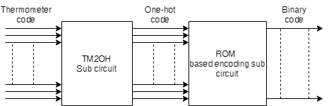

1. Block diagram of Rom encoder [7]

* TM2OH Sub circuit convert the thermometer code to ‘One-Hot code’.
* Then ‘One-Hot code’ is converted to binary code by rom-based encoding [7]

*Priority Encoder:* For this encoder if one or more than one inputs are equal to ‘1’ at same time then input with highest priority will take a lead.

### Sampling and Hold Circuit

For the conversion of analog input to digital the supply must be constant. So this circuit take a sample of the signal and hold it till conversion takes place. [8]

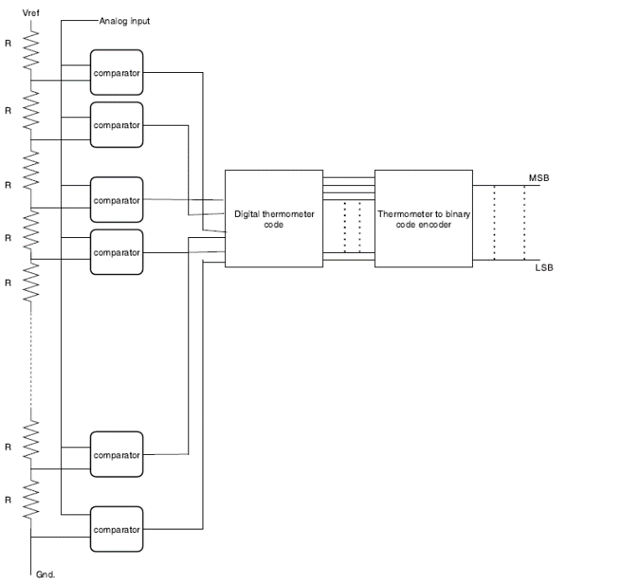

1. Circuit diagram of Flash ADC [6]

## Successive Approximation ADC

It is a high-speed analog to digital converter which basically works on a particular algorithm or on a feedback algorithm for conversion of analog input to digital form. The number of clock pulses required by this type of ADC is equal to the no. of bits of ADC.

Its circuit is divides into 4 parts:

### Successive-approximation register(SAR) and control unit

The SAR is a basic register which is used to store the values according to the logic unit. Initially control unit set the value of MSB of SAR to ‘1’ and rest of the other bits to ‘0’. [9-10]

### Digital to analog converter (DAC)

This circuit basically converts the digital input which it gets from the SAR to analog form which acts as a reference voltage ($V_{ref}$) for the comparator. [9-10]

### Comparator

At the positive terminal of comparator, analog voltage (vin) is supplied which is to be converted into digital form and at the negative terminal of the comparator the reference voltage from DAC is supplied .The comparator produces output ‘1’ when the $V_{in}>V_{ref}$ else when $V_{in}<V_{ref}$ it produces output ‘0’. [9-10]

Initially SAR’s MSB is set to ‘1’ and all other bits to ‘0’ then DAC take the value stored in SAR and convert it to analog form for the comparison. The comparator compares the $V_{in} and V_{ref}$ and produces the output accordingly and send its output to the control logic unit where it performs operation on SAR as: [9-11]

* If $V_{in}>V_{ref}$ then set the next bit of the SAR to ‘1’.
* Else if $V_{in}<V_{ref}$ then reset the current bit (change it to ‘0’) and set the next bit to ‘1’.

And the cycle repeats for n clock pulses (where n is the no of bits of ADC), and we get the output in digital form. [9-11]

### Sampling & hold circuit:

For the conversion of the analog input to digital output the supply of Vin must be constant. So this circuit take a sample of the Signal and hold it till the conversion takes place [10].

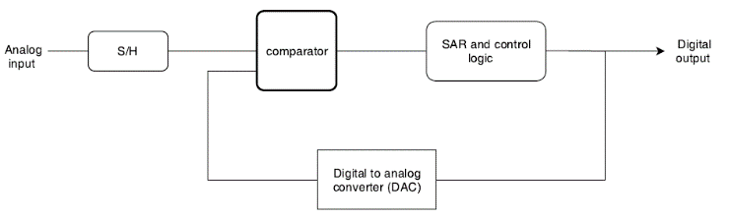

1. Block diagram of Successive Approximation ADC [10]

## Delta-Sigma Analog to Digital Convertor

Delta Sigma Analog to Digital Convertor is a type of Oversampling Convertor which means it has rate of sampling the input signal multiple times than Nyquist convertor. Delta-Sigma Convertor is a high resolution, low cost, low power consumption convertor. It is called Delta-Sigma because it has at least one integrator and one comparator (1-bit ADC). This type of ADC is the most famous in the recent years because of its low cost and high resolution.[12-13]

It has two main component which are

### Delta-Sigma Modulator

It contains differential amplifier, integrator, comparator, 1bit DAC. It takes analog signal as input and reduce quantisation noise by sampling it at frequency much higher than Nyquist rate. It converts the analog signal to pulse frequency. Input signal goes to low resolution 1-bit ADC/comparator through differential amplifier and integrator. The output is feedback to differential amplifier through 1-bit DAC as ‘1’ if output is ‘1’ else ‘-1’ if output is ‘0’[12-13]. It achieves higher efficiency by transmitting only the difference between two consecutive signals rather than actual sample [14]. Figure 6 shows the block diagram [13].

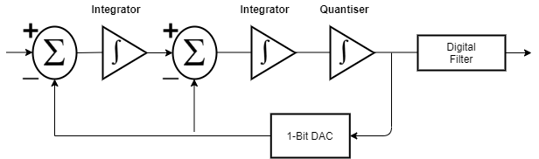

1. Block Diagram of second order delta sigma convertor [13]

### Decimation Filter/Digital Filter

The output from modulator comes into Decimation filter to convert into digital signal. It is called decimation filter because it decimates/reduces the oversampling frequency to Nyquist frequency to avoid aliasing effect. Decimation filter also does Noise Shaping which is pushing unwanted noise out of bandwidth of interest.[12],[14]

## Comparison Analysis

There are many types of ADC are available in market for different purposes. For battery management system there are mainly three types of ADC are used which are Flash ADC, Successive Approximation ADC, Delta-Sigma ADC.

To select from these we use some key factors to compare like Resolution, Accuracy, Quantisation Noise, Sampling Speed.

### Resolution

Resolution is the smallest increment corresponding to 1 least significant bit change. In other word, it determines how many bits are producing by A/D convert in one conversion.

### Accuracy

Accuracy of A/D convert determines closeness of measured digital output with expected digital output for given input. Accuracy depends on the quantisation noise, extra noises.

### Quantisation Noise

Quantisation Noise is the unwanted voltage in output of A/D convertor. It is an error between analog input voltage and digital value. It is dependent on sampling rate. If we increase sampling rate, then noise reduced [12].

### Sampling Speed

Sampling Speed is the highest number of conversions made in one second.

### Power Consumption

Power Consumption basically tells us about the power used to convert analog value to digital value. Cost of converting depends upon power consumption. Higher power consumption means that higher cost.

### Cost

Cost is also a very important aspect when choosing a perfect A/D convertor.

1. : Comparison analysis of A/D convertor

|  |  |  |  |
| --- | --- | --- | --- |
| Types of  ADC | Flash ADC | Successive Approx. | Delta-Sigma ADC |
| Precision | 8-bit | 8-16 bit | Upto 32 bit |
| Accuracy | Mid-High | High | Mid-High |
| Sampling Speed | Highest | Moderately High | Low |
| Quantisation Noise | Moderate | Low | Moderate |
| Power Consumption | High | Medium | Low |
| Cost | High | Medium | Low |

12-bit delta-sigma A/D convertor is used in electric vehicle because of its low cost, low power consumption, high resolution.

# Measuring Current

Sensing of current in a battery management system help us to monitor the safety of the battery and calculate the state of charge (SOC) of the battery and State of health (SOH) of the battery. We cannot measure electric current directly so we measure it in the form of voltage (by ADC) and then convert it into current.

There are various types of current sensing techniques two of them are listed here:

## Shunt Current Sensor

This is the most accurate approach of measurement of current in the battery. A shunt is resistance of very low value approximately in milliohm’s which is connected in series with the battery [15]. This method is suitable for measuring of alternating current as well as direct current. Here current is computed by calculating the voltage drop (VSH) across the shunt resistor, and then dividing it by the resistance of shunt, basically It work on Ohm’s law (V=IR) [15] mathematically:

$$I_{SH}={V_{SH}}/{R_{SH}}$$

Here we have taken the value of shunt resistance very low to minimize the heating losses (I2R). So before the measurement of current we should amplify the voltage accordingly for calculation of current. [15-16]

A basic Prototype of shunt resistor in which there are two big terminals at the top in which one terminal is connected to the negative / positive of the battery stack, and another to the output negative terminal of battery pack .And by the two small screws shunt resistance can be adjusted for the measurement of current in the battery. [16]

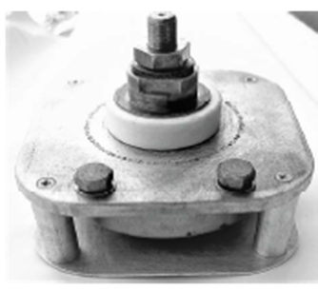

1. Shunt Current Sensor [16]

## Hall effect Sensor

This sensor basically works on the principle of Hall Effect according to which if magnetic field (B) pass through current carrying conductive material then a voltage is induced which is perpendicular to magnetic field(B), and current(I). $\left[V={\left(I×B\right)}/{\left(N×q×d\right)}\right]$ where q is the charge on sheet, n is the no. of current carriers and d is the thickness of the sheet. Here the voltage induced is directed to the current so it can be used for the measurement of current [15]. Hall effect sensor is used to measure DC current specially.

Measurement of current by Hall Effect sensor is not so accurate because due to induced voltage it is hard for the sensor to sense the fast-changing magnetic field, for reduction of this problem the effective area of interaction between hall plate and conductor must be reduced [17].

A wire from the battery terminals is subjected to the oval opening in the starting of sensor then the wire goes along the centre of the sensor where by Hall Effect voltage induced by the interaction of magnetic field from hall plate and current carrying wire and is measured but the wire or conductor and the sensor are electrically-isolated from each other, then with the help of A/D we get our output in digital format [15], [17].

# Measuring Temperature

Temperature is an important value to be measured because cells functionality, degradation rate, charging speed, thermal management depends on temperature. Unexpected temperature change can lead to cell failure. We cannot measure temperature directly either so we use sensor which measure in the form of either voltage or resistance. There are two main sensors which are used to measure temperature. One is thermocouple which measures temperature in the form of voltage and other is thermistor which measures temperature in the form of resistance [2].

## Thermistor

Thermistor is a resistance thermometer, which means that this sensor measures temperature in the form of resistance. Thermistor is a high accuracy sensor. It is used for measuring temperature in the range from -30 degree to 120 degrees. However, thermistor is most stable when used in the range of -20 to 50 degree. It is used in automobile industry because of its low cost and reliability. We cannot measure resistance directly so we use voltage divider to measure resistance and then it is used to measure temperature. Usually thermistor is used with a reference resistor in order to use voltage divider. Voltage is used in voltage divider to measure resistance and then temperature is measured according to resistance value [18]. According to relationship between resistance and temperature, thermistor is of two types:

### Positive Temperature Coefficient (PTC)

This type of thermistor is called as positive temperature coefficient thermistor because its resistance is increases with increase in temperature. It is simple and easy to measure because of its linear characteristics between resistance and temperature. Their tolerance spread is quite large therefore it has low accuracy [18]. PTC thermistor is divided into two group based on material, manufacturing process and structure. First group is silistor which used as PTC for linear characteristics comprises silicon as semiconductor and second group is switching type which used in sensors. The range in which mostly PTC used is between 60 degrees to 120 degrees.

### Negative Temperature Coefficient (NTC)

Negative Temperature Coefficient Thermistors are inversely proportional which means that its resistance is decreases with increase in temperature. They have narrow tolerance spread therefore they are high accuracy thermistors. However, they are complex to measure because their resistance variation covers three order of magnitude as compare to PTC which covers one order of magnitude. It has non-linear dependency of temperature with resistor. They perform well in the range between -50 degree to 250 degrees therefore they have wide variety of application and they are also more accurate and cost effective [18].

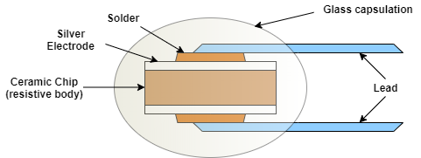

1. Ceramic type NTC thermistor[19]

## Thermocouple

Thermocouple is a device which is used for measurement of the temperature of the battery cells and work on seebeck effect according to which voltage is induced in a wire if there is a temperature difference between two ends of that wire. It measures battery cells temperature as this sensor or device consist of two wires (A&B) of different material which are connected to two different nodes or junction (T1 & T2) [20].

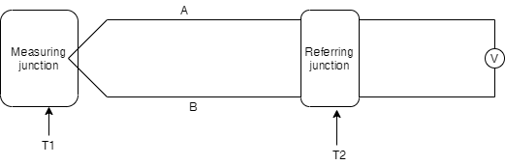

1. Thermocouple [20]

So here we can say that the node T1 is that point where our battery cells temperature is to be measured also known as ‘hot junction or measuring junction’ and T2 is that node which has a constant temperature and work as referring node also called as ‘cold junction’. So from junction T1 wires A, B get heat and when their temperature is compared at junction T2 then a voltage (Vind) is induced proportional to the temperature difference, and then this induced voltage is further amplified as Vind has very low value and then with the help of analog to digital converter this voltage is measured in digital form which corresponds to the value of temperature of the battery cells. We can take different type of this thermocouple sensor type A, type C, type G, type K and many more according to the voltage-temperature characteristics of our battery. This method of measurement of battery cells temperature is not so accurate in some cases if the cold junction (T2) temperature is affected by the surrounding temperature then there can be error in the voltage induced which further lead to incorrect value measurement by ADC. [20]

# Conclusion

In this paper, we studied about battery management system that how it is very important in smart grid industry, renewable energy industry, electronics industry, automobile industry etc. We studied about the sensing functionality of BMS in which it measures/sense voltage, current and temperature and as we know that these values are required to estimate SOC, to avoid thermal runaway, fast charging (at low temperature charging speed is low), to monitor battery pack safety. It was concluded that voltage is measured by A/D convertor. There are three types of ADC to measure voltage and we saw the working of all three and saw how they are different from one another.

We cannot measure current and temperature directly so with the help of sensors these values are first converted into voltage or resistance and then they are measured by ADC.

##### References

1. Farjah and T. Ghanbari, "Early ageing detection of battery cells in battery management system," in Electronics Letters, vol. 56, no. 12, pp. 616-619
2. Gregory L. Plett: ‘Equivalent circuit methods, battery management system’, Artech House publication, volume-2, 2015
3. S. M. Qaisar, D. Dallet, S. Benjamin, P. Desprez and R. Yahiaoui, "Power efficient analog to digital conversion for the Li-ion battery voltage monitoring and measurement," 2013 IEEE International Instrumentation and Measurement Technology Conference (I2MTC), Minneapolis, MN, 2013, pp. 1522-1525
4. X. Li, D. xu, H. Zhu, Z. Chen, Z. Yang, X. Cheng, Y. Yu and W.T. Ng "A high voltage multiplexer with rail to rail output swing for battery management system applications," IEICE Electronics Express, January 2017, Volume 14, No. 1, 1-8
5. M. A. Hannan, M. M. Hoque, A. Hussain, Y. Yusof and P. J. Ker, "State-of-the-Art and Energy Management System of Lithium-Ion Batteries in Electric Vehicle Applications: Issues and Recommendations," in IEEE Access, vol. 6, pp. 19362-19378, 2018
6. Laxmi Kumre, N.V. Ramesh, ”Design and Implementation of Flash Analog to digital Converter”, in Materialstoday : Proceeding conference, Volume 5, Issue 1, pp. 1104-1113
7. M. P. Ajanya and G. T. Varghese, "Thermometer code to Binary code Converter for Flash ADC - A Review," 2018 International Conference on Control, Power, Communication and Computing Technologies (ICCPCCT), Kannur, 2018, pp. 502-505
8. A. Inamdar, A. Sahu, J. Ren, S. Setoodeh, R. Mansour and D. Gupta, "Design and Evaluation of Flash ADC," in IEEE Transactions on Applied Superconductivity, vol. 25, no. 3, pp. 1-5, June 2015
9. M. Borgarino, L. Giacomini, G. Luppi, F. Digiaro, J.B. Begueret, N. Verrascina, “Clock-less 8-bit SAR-ADC with delay-line based digital control circuit”, Microelectronics Journal, Volume 94, December 2019, 104641
10. Hui-WenChang, Hong-YiHuang, Yi-HsiangJuan, Wei-SongWang, Ching-Hsing Luo, “Adaptive successive approximation ADC for biomedical acquisition system”, Microelectronics Journal, Volume 44, Issue 9, September 2013, Pages 729-735
11. Y. Sundarasaradula, T. G. Constandinou and A. Thanachayanont, "A 6-bit, two-step, successive approximation logarithmic ADC for biomedical applications," 2016 IEEE International Conference on Electronics, Circuits and Systems (ICECS), Monte Carlo, 2016, pp. 25-28
12. N. Gandhi and S. D. Shelke, "Sigma delta analog to digital converter: Design and implementation with reduction in power consumption," 2017 International Conference on Trends in Electronics and Informatics (ICEI), Tirunelveli, 2017, pp. 1035-1039
13. Wikipedia

<https://en.wikipedia.org/wiki/Delta-sigma_modulation>

1. Electronic Design

<https://www.electronicdesign.com/technologies/analog/article/21798185/understanding-deltasigma-modulators>

1. S. Ziegler, R. C. Woodward, H. H. Iu and L. J. Borle, "Current Sensing Techniques: A Review," in IEEE Sensors Journal, vol. 9, no. 4, pp. 354-376, April 2009
2. S. Shalamov, "Current Measuring Shunts for Impulse Current Test According to IEC 62305–2010," 2018 9th International Conference on Ultrawideband and Ultrashort Impulse Signals (UWBUSIS), Odessa, 2018, pp. 127-130
3. M. Sen, I. Balabozov, I. Yatchev and R. Ivanov, "Modelling of current sensor based on hall effect," 2017 15th International Conference on Electrical Machines, Drives and Power Systems (ELMA), Sofia, 2017, pp. 457-460
4. S. Nieddu, "High accuracy-wide range resistance measurement for thermistor sensors monitoring," 2012 IEEE International Instrumentation and Measurement Technology Conference Proceedings, Graz, 2012, pp. 1988-1993
5. F. Mo and W. Cai, "A failure analysis of the NTC thermistors," 2017 18th International Conference on Electronic Packaging Technology (ICEPT), Harbin, 2017, pp. 912-915
6. G. C. Sârbu and O. Beniugă, "Evaluating measurement uncertainty of thermocouples calibration," 2018 International Conference and Exposition on Electrical and Power Engineering (EPE), Iasi, 2018, pp. 0411-0415